Operating System Lab Assignment 1

Assignment 1(a):-
Write a C program to create a child process using the system call fork( ). From the child process, display the PID and PPID and then call again the fork( ) to create a grandchild and engage him to display your roll no. From parent display the PID and PPID of all the processes and display the count of total no. of child processes created also the number of grandchild processes created. Demonstrate the use of exit(0) and exit(1).
Ans:
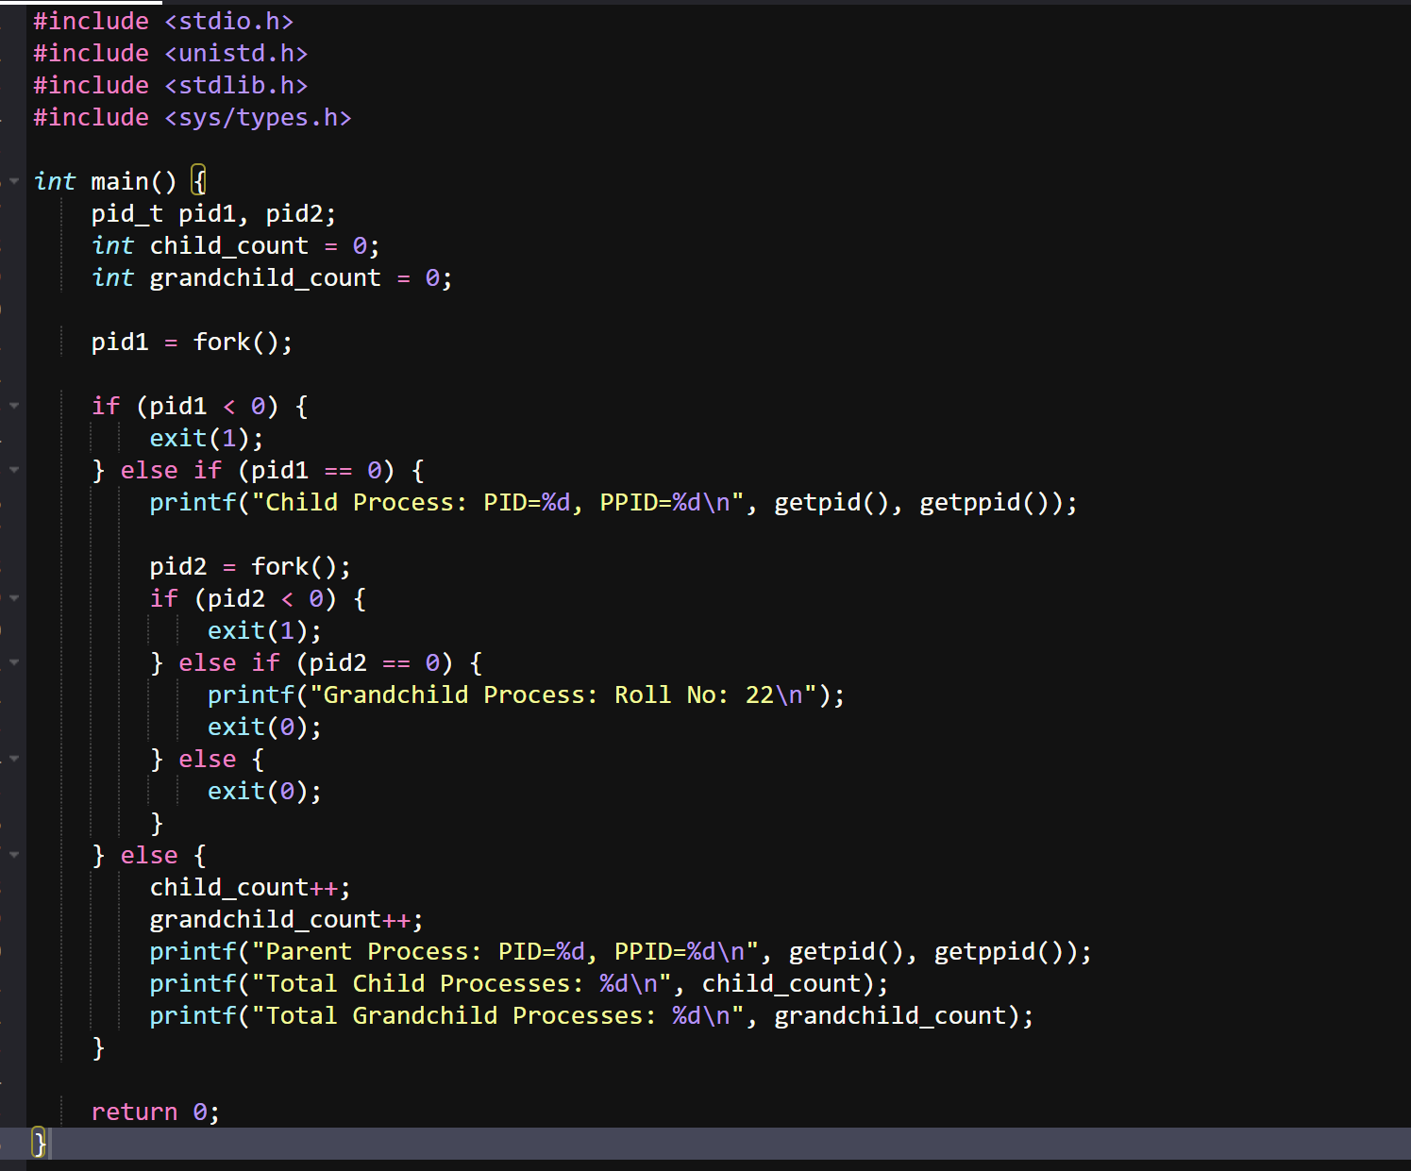
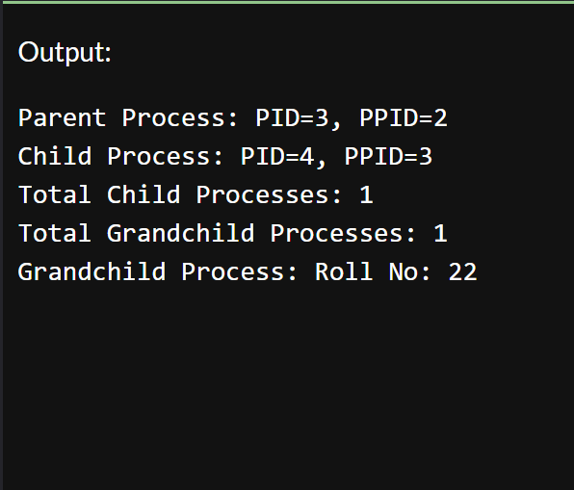

Assignment 1(b):-
Write a C program like the assignment 1(a). But here use the system call wait() system to synchronize the execution of parent program in your program until child process finishes. Now write a function to print to find out who is logging in the local machine that is partially equivalent to the cmd "w" or "who" and engage the grandchild to print the output into the stdout.
Ans:

